Chapter 2:

Administrator Tasks

In this section we will cover the basic tasks that users perform:

* Create a user account
* Delete a user account
* Disable a user account
* Create a group
* Add users to a group
* Remove users from a group
* Create new messages
* Delete messages
* Retrieve experiment results
* Retrieve login records
* Retrieve user session information
* Run Group Reports

# Create a user account

While most users will register for their own accounts, sometimes it is necessary to create one or more user accounts.

1. Login to the Service Broker as administrator.
2. Click the Users & Groups Tab.
3. Click the Manage Users tab.
4. Enter the user information for the account.

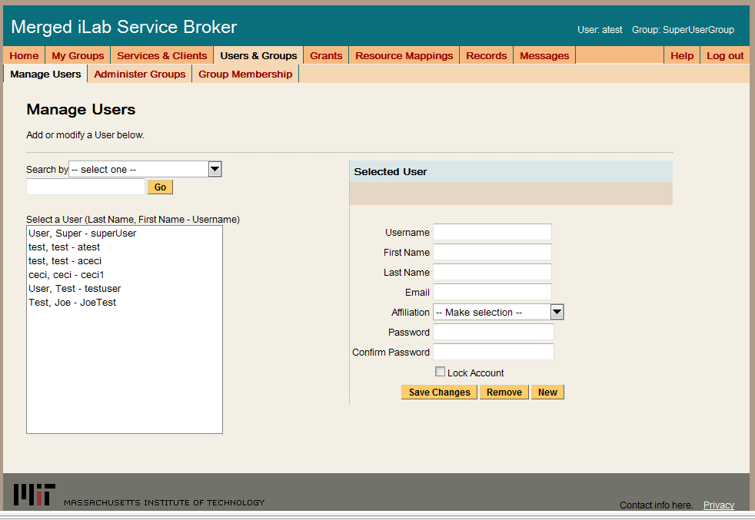

|  |  |
| --- | --- |
| **Field Name** | **Field Description** |
| Username | Pick the user name using any UTF-16 characters. Usernames can not be changed. |
|  |  |
|  |  |
| First Name | User’s first name |
| Last Name | User’s last name |
| E-mail | User’s e-mail address. It is important that a valid e-mail is associated with each user account. |
| Affiliation | Choose the appropriate description, choices include Student, Staff/Faculty, Guest, and Other. This list can be modified in the web.config file. |
| Requested Group | This drop down list contains the list of groups that can be requested. Users who want to request multiple groups can do so once their account has been created. |
| Password | User’s password. User password cannot be recovered. There is an automated utility for resetting a user’s password and emailing it to the email address associated with the account. |

1. Select the Save Change button.
2. A green bar at the top of the page should indicate that you have successfully created a new user.



# Delete a user account

1. Login to the Service Broker as administrator.
2. Click the Users & Groups Tab.
3. Click the Manage Users tab.
4. Select the Username from the list or find the username by searching.

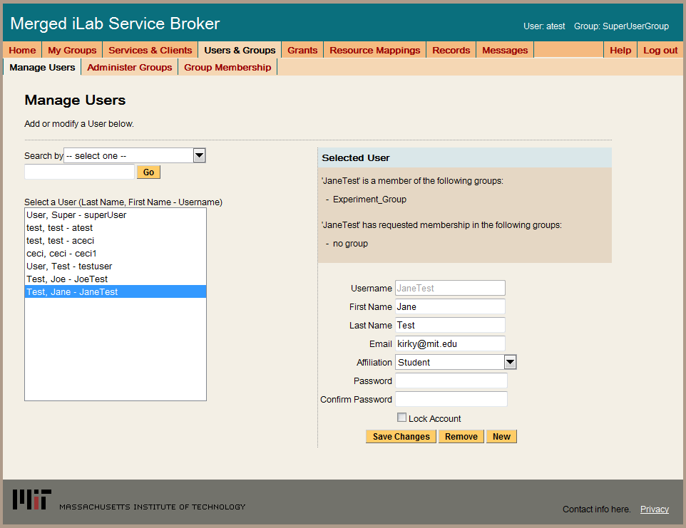

1. Select the Remove button. Once an account has been removed it cannot be recovered. Removing a user will delete all experiment records.
2. Click on the OK button in the popup message window.

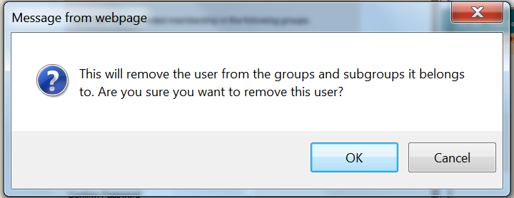

1. A green bar at the top of the page should indicate that you have successfully removed the user.



# Disable a user account

To prevent a particular user from logging on for security reasons, you can disable user accounts rather than deleting user accounts. Users can not login to a disabled account.

1. Login to the Service Broker and select the SuperUser group.
2. Click the Users & Groups Tab.
3. Click the Manage Users tab.
4. Select the Username from the list or find the username by searching.

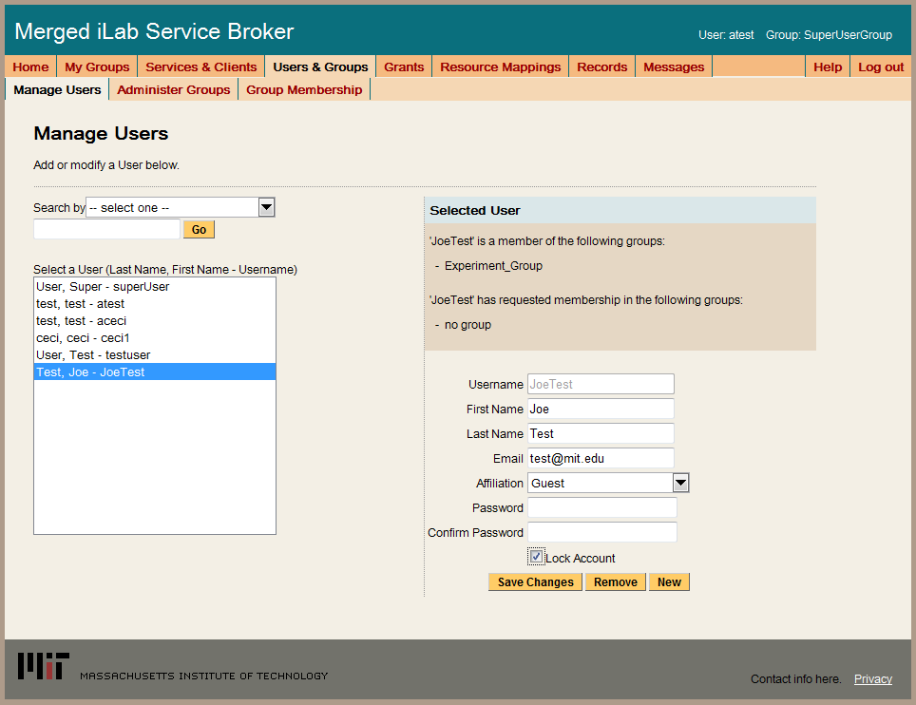

1. Check the box next to Lock Account.
2. Click on the Save Changes button.
3. A green bar at the top of the page should indicate that you have successfully removed the user.



# Create a group

There are two types of groups: user groups and administrator groups.

1. Login to the Service Broker and select the SuperUser group.
2. Click on the Users & Groups tab on the main menu of the Service Broker.
3. In the sub-menu, select the Administer Groups tab.
4. Select either the Add Group button or the Add Service Admin Group button.

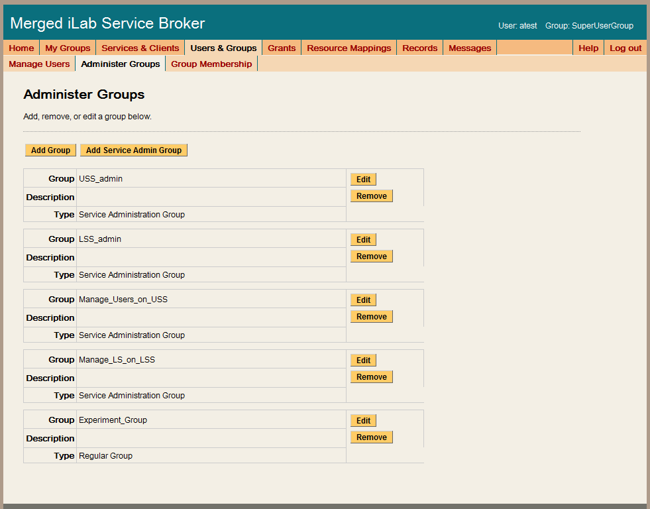

1. Enter the group information.

|  |  |
| --- | --- |
| **Field Name** | **Field Description** |
| Group Name |  |
| Description |  |
| Admin Contact Email |  |
| Need Request Group?  Need Course Staff Group? |  |
| Direct Group Membership |  |

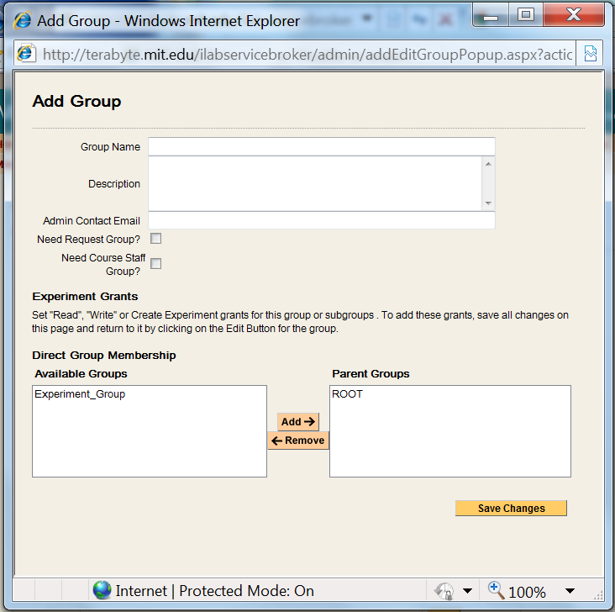

1. When finished, click on the Save Changes button. The new group should be listed on the Administer Groups page.
2. For User groups, there is an additional step. You need to give the group permission to create and store experiments.
3. In the Administer Groups window, click on the Edit button of the group you just created. A popup window will appear. Notice that there is now an Experiment Grant section.
4. Click on the boxes next to the R, W and C to grant permissions.

R Read Experiments

W Write Experiments

C Create Experiments

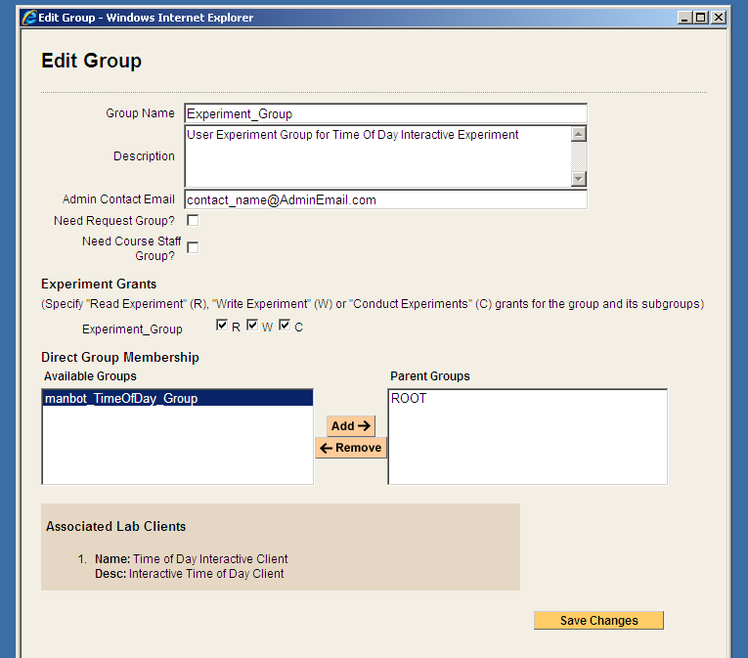

1. When finished, click on the Save Changes button.

# Add users to a group

|  |  |
| --- | --- |
| Copy To -> | Copy To -> adds the user to the selected group(s) but leaves the user in the existing group. |
| Move To -> | Move To -> adds the user to the selected group(s) and removes the user from the existing group. |
| <- Remove | <- Remove deletes the user from the selected group. If the user is no longer associated with any group, the user is moved to the OrphanedUserGroup. |

1. Login to the Service Broker and select the SuperUser group.
2. Click on the Users & Groups tab on the main menu of the Service Broker.
3. Click the Group Membership tab.
4. In the left hand “Users and Groups” tree, click the + sign next to the group you are interested in working with to locate the user. If this is a new user, open the NewUserGroup.

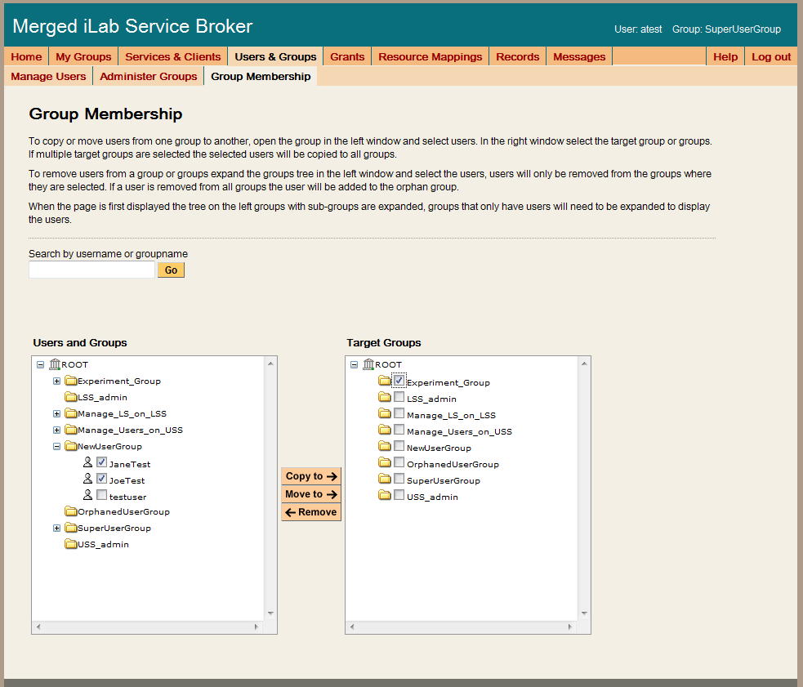

1. Click on the box next to the username. You can move multiple users at the same time.
2. In the right side “Target Groups” tree, select the box next to the group where the user is to be moved. You can select multiple targets.
3. Click on the Move To -> button, if the username is in the NewUserGroup (or subgroup) otherwise click on the Copy To -< button.



1. A green bar at the top of the page should indicate that you have successfully added the user to the group.
2. In the left hand “Users and Groups” tree, the test user should now appear in the designated Group.

# Remove users from a group

1. Login to the Service Broker and select the SuperUser group.
2. Click on the Users & Groups tab on the main menu of the Service Broker.
3. Click the Group Membership tab.
4. In the left hand “Users and Groups” tree, click the + sign next to the group you are interested in working with to locate the user.

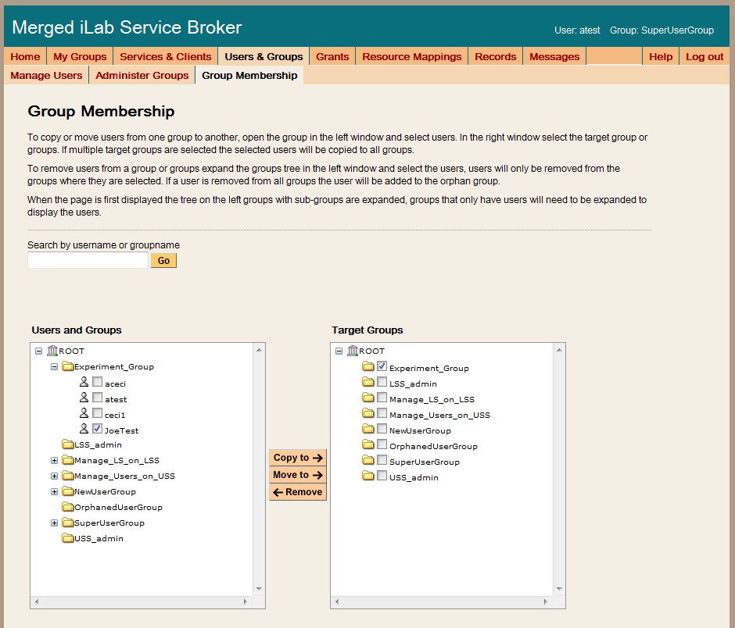

1. Click on the box next to the username. You can remove multiple users at the same time.
2. In the right side “Target Groups” tree, select the box next to the group where the user is to be removed from.
3. Click on the <- Remove button.

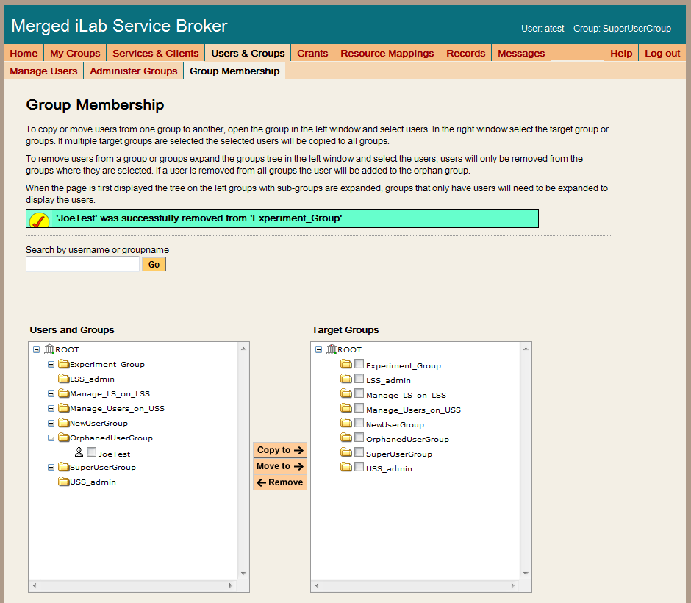

1. A green bar at the top of the page should indicate that you have successfully removed the user from the group.
2. If the user was not in any other groups, the user will appear in the OrphanedUsersGroup.

# Create new messages

Messages allow administrators or faculty to communicate with users on the Service Broker. Messages can be saved and reused by using the Display Message check box. If the Display Message box is checked, the message will be displayed. If the Display Message box is not check, the message will not be displayed. There are three types of messages available in the Service Broker.

|  |  |
| --- | --- |
| Group | Group messages appear on the My Clients page and are associated and displayed for a particular group. |
| Lab Server | Lab server messages also appear on the My Clients page and are displayed for every group that uses a particular experiment regardless of the client. |
| System | System messages are displayed on the Service Broker home page. |

1. Login to the Service Broker and select the SuperUser group.
2. Click on the Messages tab on the main menu of the Service Broker.
3. Select the type of message (group, lab server or system) being created.

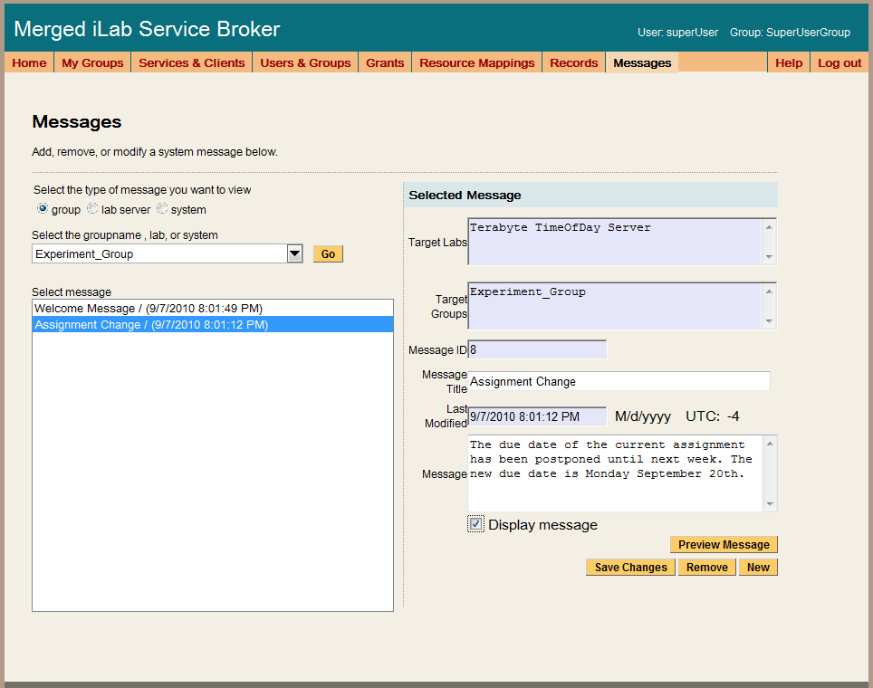

1. If this is a group or lab server message, select the group/lab server from the pull-down list.
2. Click on the Go button. All existing messages will be listed in the message area. Notice that the Target Labs and the Target Groups have been filled in.
3. Enter a title for your new message in the Message Title box. This should be clear and concise.
4. Enter your message.
5. Click on the box next to the Display message.
6. Click on the Save Changes button to save your message.
7. A green bar at the top of the page will indicate that you have successfully created.



# Delete messages

1. Login to the Service Broker and select the SuperUser group.
2. Click on the Messages tab on the main menu of the Service Broker.
3. Select the type of message (group, lab server or system) being deleted.



1. If this is a group or lab server message, select the group/lab server from the pull-down list.
2. Click on the Go button. All existing messages will be listed in the message area.
3. From the Message select are, click on the message to be deleted. Once a message is deleted it cannot be retrieved.
4. Click on the Remove button.

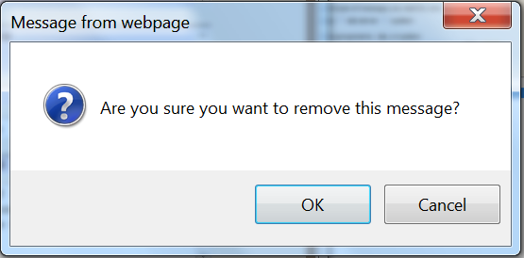

1. Click on the OK button in the popup message box to confirm the message deletion.
2. A green bar at the top of the page will indicate that you have successfully deleted.



# Retrieve experiment results

Sometime faculty and/or administrators need to access student experiment results to assist students. Administrators and group TA’s have permission to annotate experiment results.

1. Using any browser connected to the internet, login to your local Service Broker.
2. Click on the "My Experiments" tab in the main menu.



1. In the Search Experiments form in the left hand column, use the scroll bar to select an experiment based on the date and time it was run.

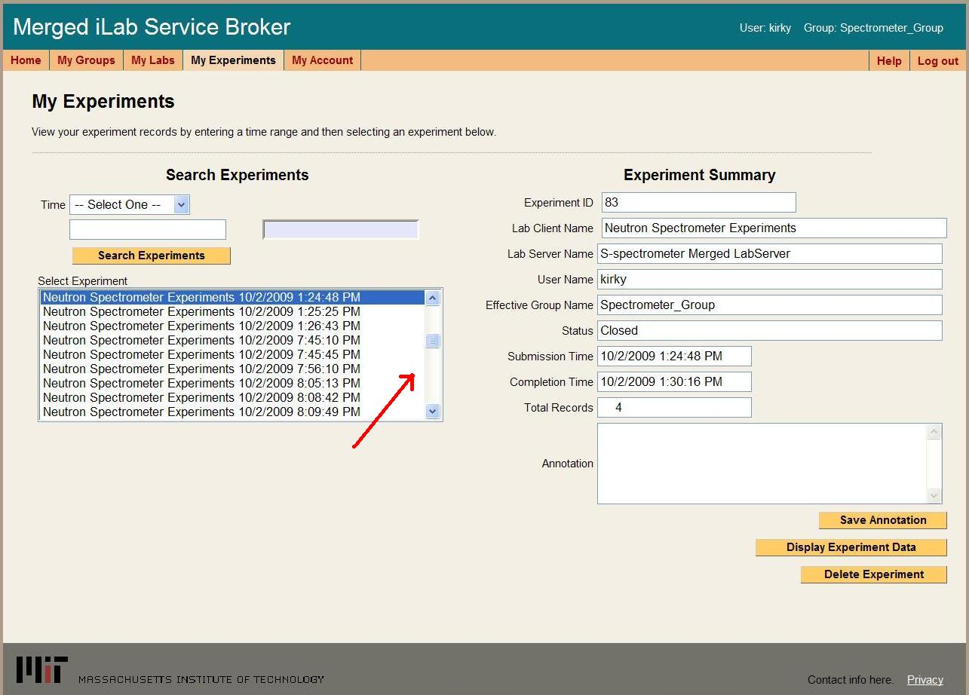

1. Once an experiment has been selected, the Experiment Summary form in the right column, will be automatically populated.
2. Click on the Display Experiment Data button.

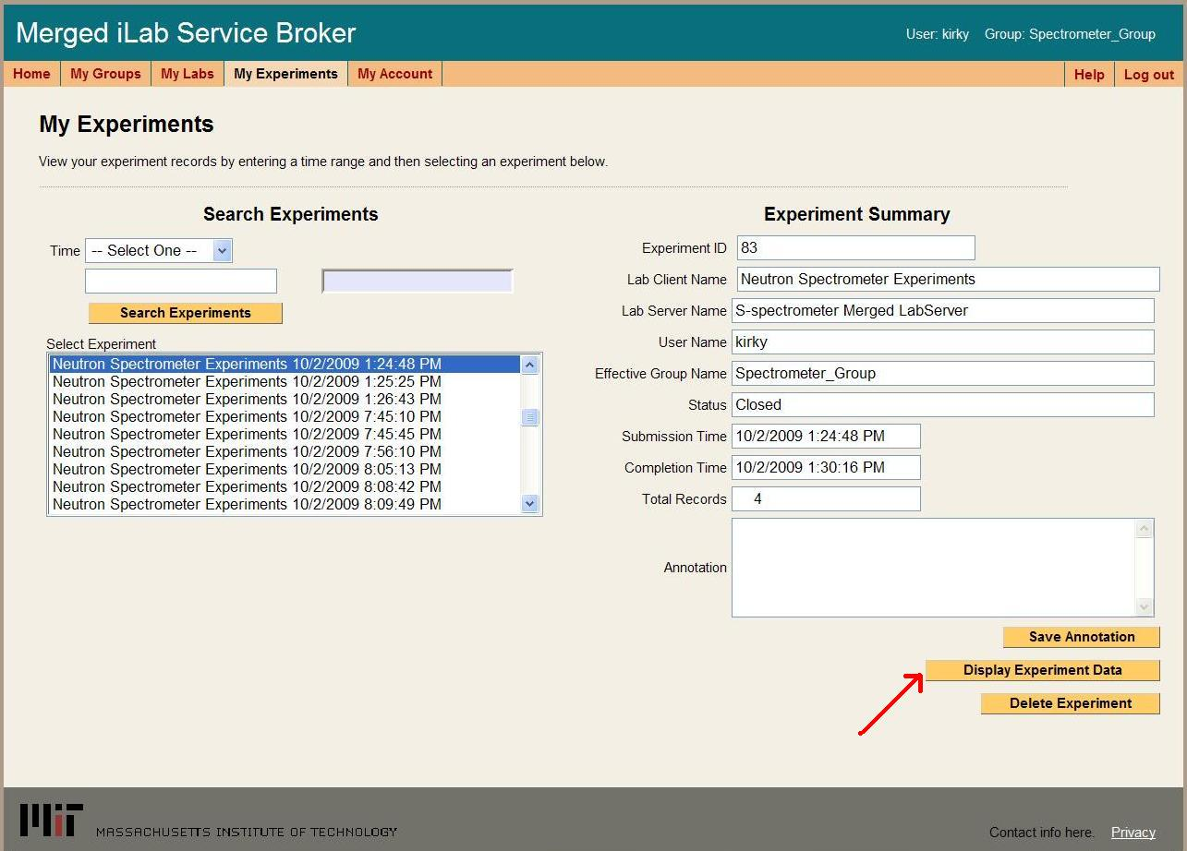

1. In the Show Experiment page, click on the Get Records button to retrieve all the records about this experiment in a table format.

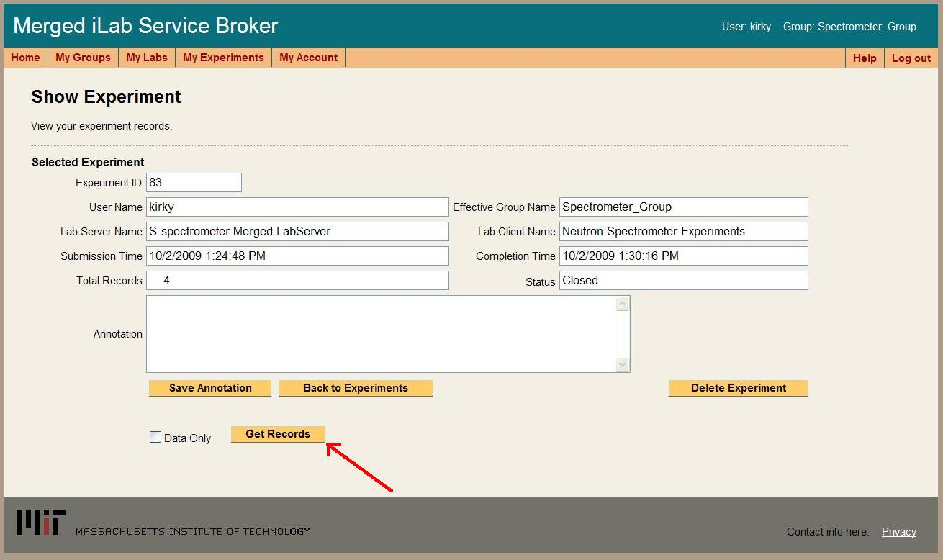

1. Records are shown is a table format for easier reading.

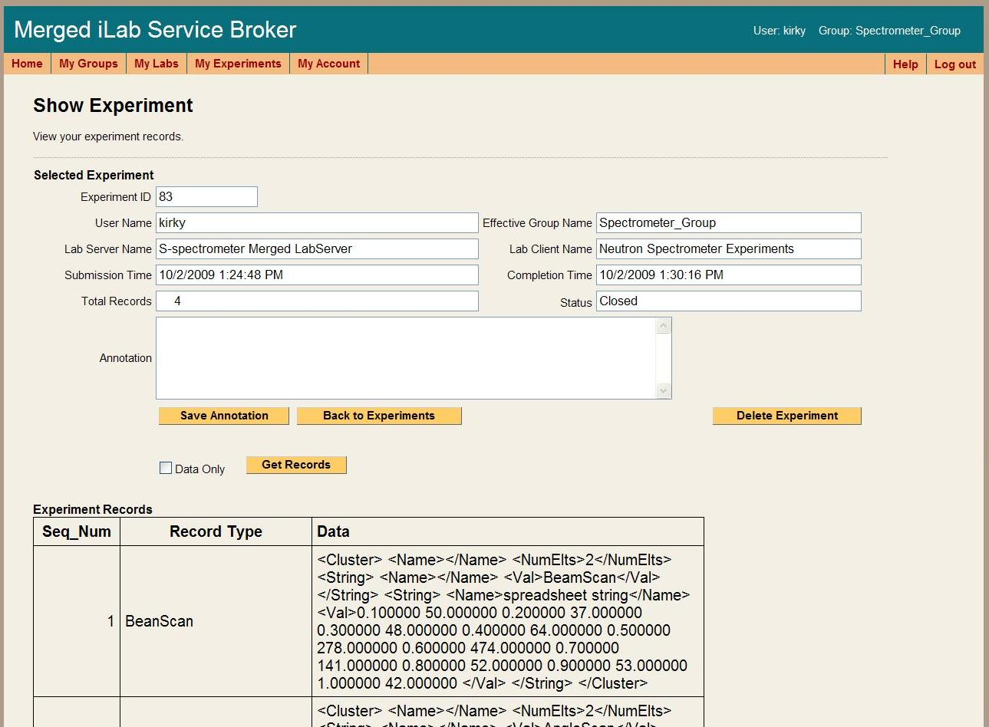

1. From the Show Experiment page, you can also display the data only records in a XML format that can be cut and pasted into another application.

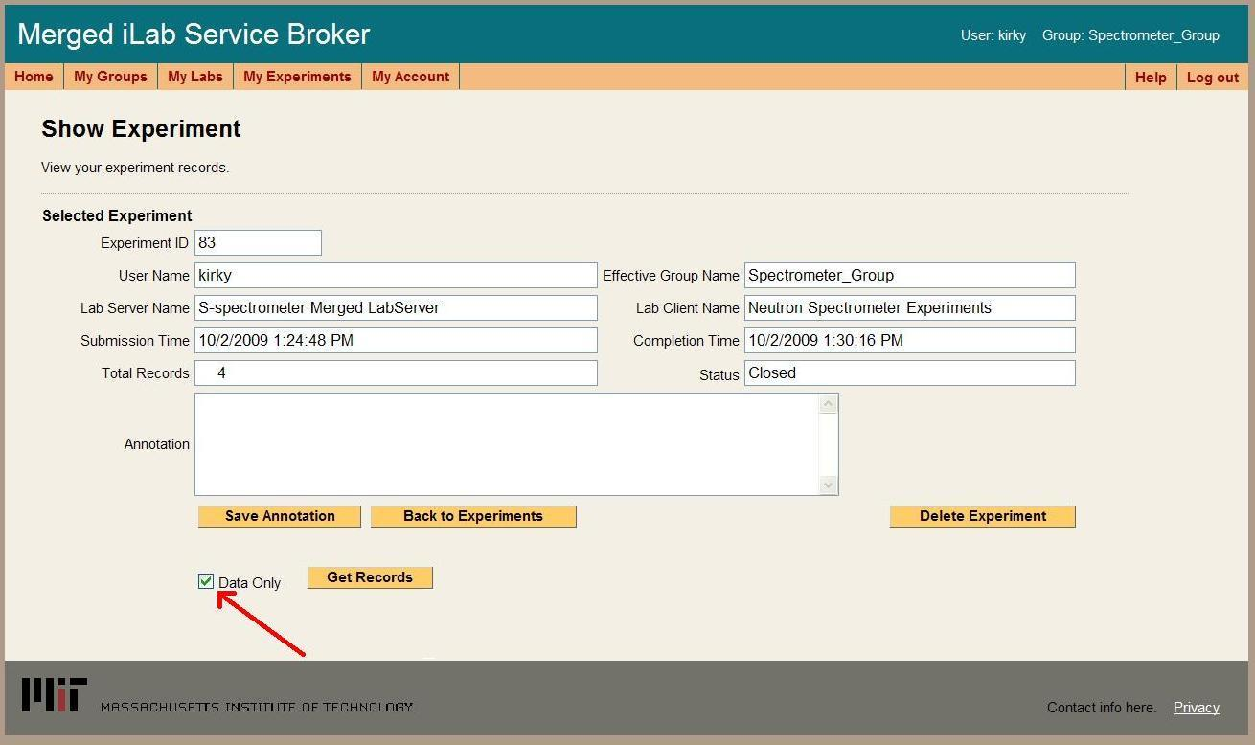

1. Click in the box next to Data Only to select it.
2. Click on the Get Records button to retrieve only the data records in a XML format.

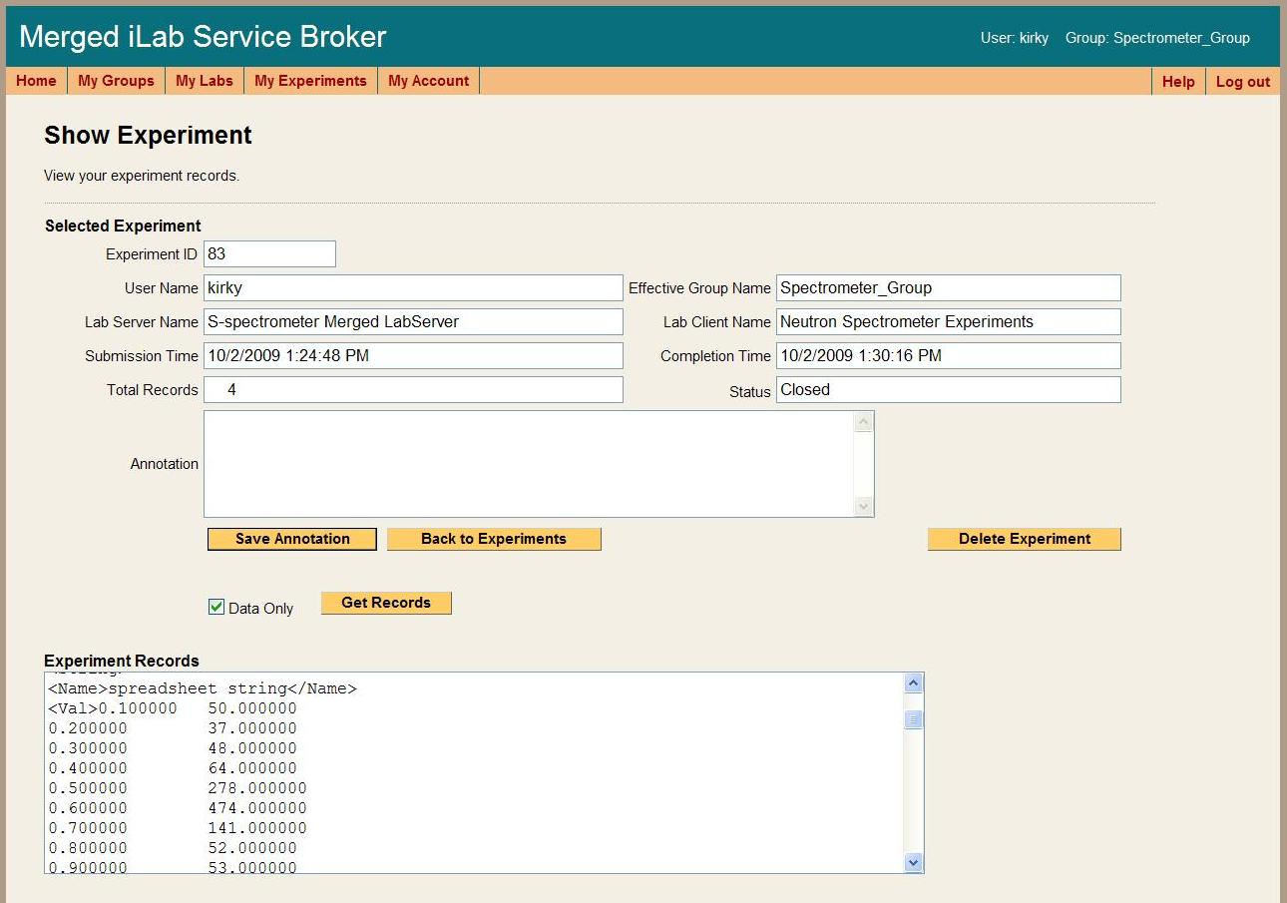

# Retrieve login records

1. Login to the Service Broker and select the SuperUser group.
2. Click on the Records tab on the main menu of the Service Broker.
3. In the Records submenu, click the Log-ins tab.

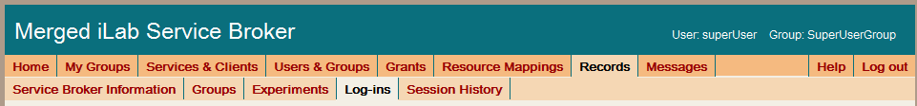

1. Enter the username of the records to be retrieved.
2. Click on the Go button.
3. The specified user’s login records will be displayed in the scroll box.

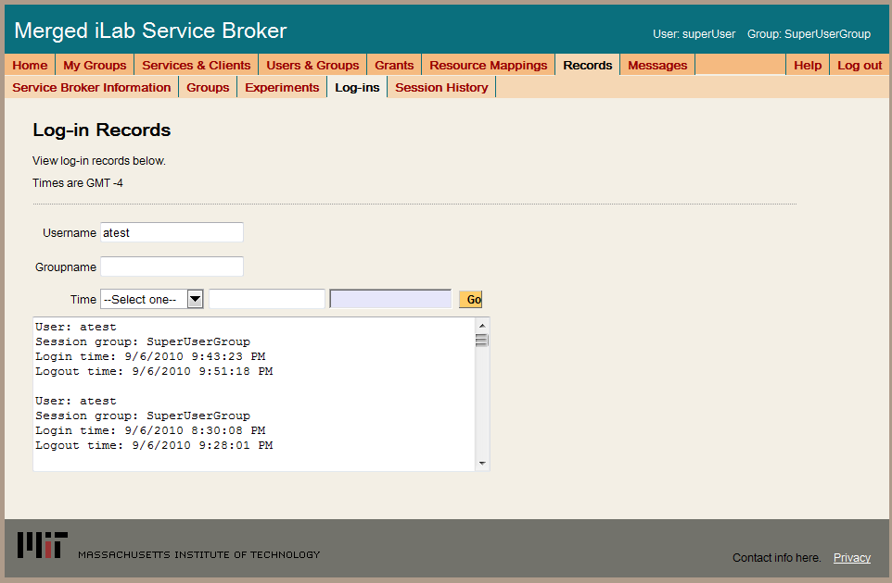

# Retrieve user session information

Session information XXXXXXXXXXXXXX

1. Login to the Service Broker and select the SuperUser group.
2. Click on the Records tab on the main menu of the Service Broker.
3. In the Records submenu, click the Session History tab.



1. Enter the username.
2. Click on the Go button.

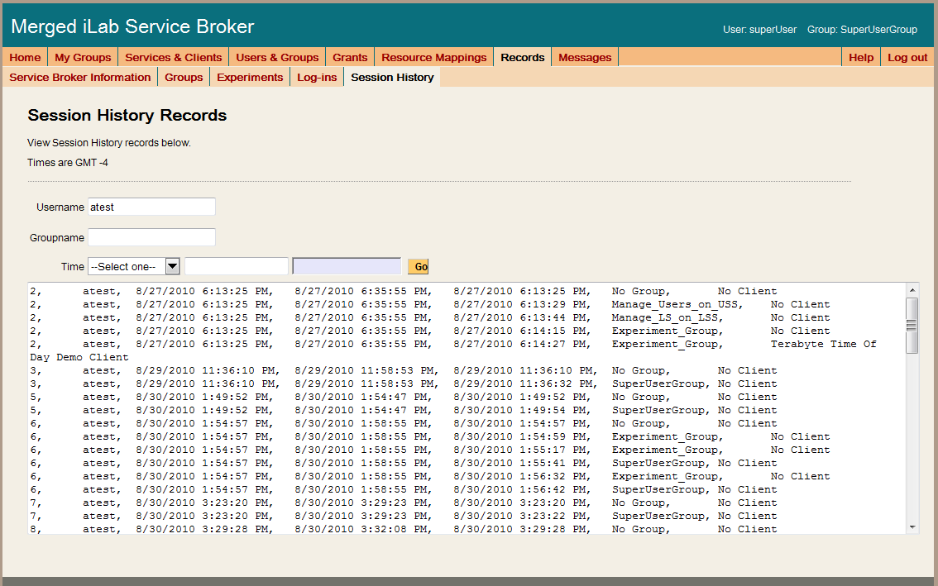

# Run Group Reports

Reports can be xxxxxxx

|  |  |
| --- | --- |
| Group Roster | This is a standard group roster including name, username, email address, and last login. |
| Group Overview | The group overview report includes user last name, first name, username, the number of logins and the number of experiment runs. |
| Group Client | Group client report includes user last name, first name, username, the number of logins and the number of experiment runs by client. |
| Group Client Column | Group client in columns report includes user last name, first name, username, the number of logins and the number of experiment runs by client in a column format for analysis. |
| Group Experiment List | The group experiment report includes experiment ID, client name, username, submission time, and completion time |
| All Group Summary | The all group summary report includes group name, number of users in group, number of user logins, total experiments run, and the breakdown of experiments run by client name. This is the only report that includes more than one group. |

1. Login to the Service Broker and select the SuperUser group.
2. Click on the Records tab on the main menu of the Service Broker.
3. In the Records submenu, click the Reports tab.
4. Select the groupname from the pull-down list.
5. Select the report from the pull-down list.
6. Click the Submit button.



1. The report will be generated and displayed. It can be exported in a tab delimitated format by clicking on the Export Tab Delimitated File.